**Online Shopping**

## CERTIFICATE OF ORGANISATION

# Appendix-1

## ACKNOWLEDGEMENT

We take this opportunity to express my gratitude to all those people who have been directly and indirectly with me during the completion of this Industrial Training.

We pay a special thanks to my guide, Mr. Devendra Soni, who has given guidance and a light to us during this training. Their versatile knowledge about ‘Time Machine’ has eased us in the critical times during the span of this training.

We acknowledge here out debt to those who contributed significantly to one or more steps. We take full responsibility for any remaining sins of omission and commission.

## Summary

The main purpose behind the proposed system is to provide a comprehensive computerized system, which can capture, collate and analyze the data and evaluate the impact of the program.

The shopping cart project needs to create the shopping cart system to organize the products record and the other information about the customers. How customers can buy products from website can be recognized from their username and password. The methodology used - Database design (Sql server 2008 R2) Input design (ASP.NET with C#) and Coding (C#).

We have gained a lot of practical knowledge from this project, which we think, shall make us stand in a good state in the future.

# Appendix-2

## Table of Contents

TITLE PAGE 1

CERTIFICATE OF THE COMPANY 2

ACKNOWLEDGEMENT 3

SUMMARY 4

CHAPTER 1 – Introduction 7

* 1. Project Overview
  2. Scope

CHAPTER 2 - Company Profile 8

* 1. Introduction
  2. Policy Quality
  3. Management

CHAPTER 3 - Functional and Specific requirements 11

* 1. External Interface
     1. Hardware Interface
     2. Software Interface
  2. Non Functional Requirements
  3. Reliability
  4. Availability
  5. Performance
  6. Technologies
  7. Software System Attributes

CHAPTER 4 - Analysis & Design 15

* 1. Use Cases
     1. Context Level Diagram
     2. First Level DFD Diagram
     3. Second level DFD Diagram
     4. Login Activity Diagram
     5. Implementation View
  2. E R Diagram
  3. Database Tables

CHAPTER 5 - Conclusion 21

REFERENCES 22

APPENDICES 23

* 1. Home Page
  2. Registration Page
  3. Show Products Page
  4. Products detail Page
  5. Login Page
  6. Your Cart Page
  7. Checkout Page
  8. Confirmation Page
  9. Contact Us Page
  10. About Us Page

## CHAPTER 1- INTRODUCTION

Online shopping is the process whereby consumers directly buy goods or services from a seller in real-time, without an intermediary service, over the Internet. It is a form of electronic commerce. An online shop, eshop, e-store, internet shop, webshop, online store, or virtual store evokes the physical analogy of buying products or services at a bricks-and-mortar retailer or in a shopping centre. The process is called Business-to- Consumer (B2C) online shopping.

### Project Overview:

The shopping cart project needs to create the shopping cart system to organize the products record and the other information about the customers. How customers can buy products from website can be recognized from their username and password.

### Scope:

Online shopping is rising day by day in India. Because India is the country

where computer user's are increasing day by day so as the online shopping trends are also increasing. This project covers the online selling of cosmetics, fashion accessories,

watches etc. The project shows the product category and then product details. From the product details, the product can be added to cart and can be bought.

## CHAPTER 2- COMPANY PROFILE

### Introduction:

PSI is a global IT services company focusing on software development, IT consulting and provides offshore outsourcing solutions to enterprises worldwide. At PSI we believe that in order to benefit from offshore outsourcing, it is imperative that you continue to control the system. Our partnership led service approach, addresses the critical components which ensure a long term successful offshore IT Outsourcing strategy for our clients.

In the race for technological leadership there are no victories, only incremental milestones. Technology leaders are looking for partners who share their business vision, risk and can actually deliver consistent performance. With PSI, you can be assured of visible benefits with guaranteed success, because we deliver a successful offshore IT outsourcing model without fail.

### Quality policy:

PSI has a documented quality management system conforming to ISO 9001:2008 quality system standards. The quality system is followed & implemented as per the guidelines of ISO 9001:2008 standard. Our Quality policy is defined as under:

### ISO 9001:2008:

As an organization we are focused on developing overall procedural standards for every business function of the company wherein involving all our people and customers to provide effective and quality software development services.

Guided under ISO quality system our comprehensive evaluation & monitoring system addresses several important issues and helps our customers in the following ways:

To develop international quality management and quality assurance standards. Documentation of quality management systems software development process and methodologies.

Effective delivery and exchange of IT services with focus on total customer satisfaction.

Monitoring and analysis of project management activities to prompt any bugs and delays.

Analysis and monitoring of IT services so that they are designed delivered and maintained in accordance with customer specific requirements.

### Management:

**Puneet Mittal:**

**(MD)**

Mr. Puneet Mittal is one of the Founders & Director of Pratham Software (PSI) . He built his career while helping build the business and taking PSI to one of the most reputed software export company in Rajasthan in the span of five years. He has steered the company’s tremendous growth and leadership in the IT business in Rajasthan

### Sumeeti Mittal:

**(Director)**

Ms. Sumeeti Mittal is Co-founder of PSI. She has over 7 years of experience in IT industry. She is responsible for System Study, Design, Development, and Testing, reviewing, implementation and maintenance of software solutions developed at PSI.

### Gulab Sharma:

**(President)**

Mr. Gulab Sharma brings extensive IT industry experience having served global giants for more than 26 years. He last worked for Sun Microsystems, USA, serving them for 16 years in the capacity of Sr. Director Engineering. He has also worked with Philips, Canada and couple of other midsize companies in USA both in management and technical positions.

## CHAPTER 3- FUNCTIONAL AND NON-FUNCTIONAL REQUIREMENTS

Required website is to provide online details to the customers of the specified products. The system should satisfy the following requirements:

### General Aspects:

Authenticate User

Show Products and their details with type Website should be able to register new user. Analysis:

Authenticate user based on username & password. Keeping session track of user activity.

Maintaining the record of products.

### External Interface Requirements:

* + 1. **Hardware Interface**
       - Server side Hardware
       - Hardware Recommended by the all the software needed
       - Communication hardware to server client request.
       - Client side Hardware
       - Hardware recommended by respective client operating system & Web browser.
       - Communication hardware to communicate the server.

### Software Interface

* + - * Server side software
      * Web-Server software
      * Server side scripting tools (Support .net is mandatory)
      * Database tools (Sql Database is mandatory)
      * Compatible operating system

### Client side software

Web browser supporting Dot net

### Non Functional Requirements

* System should be able to handle multiple users.
* Login by username, password should be incorporated wherever necessary
* Should be user friendly and display easy to understand error messages

### Reliability

Data validation & verification need to be done at every stage of activity. Validation user input

### Availability

* The web application should be available anywhere and anytime.
* User Session should timeout after 20 minutes of inactivity.

### Performance

The system will be used by multiple users and may grow as time passes.

Necessary measures need to be taken to make the system as fast as possible.

### Technologies

The sections list all the technologies for the web based system. This project is a web based application that is developed in ASP.NET having Sql-Server as back- end.

Database design (Sql server 2008 R2) Input design (ASP.NET with C#) Coding (C#)

### Software:

Client Side:

.NET Framework, Web Browser,

Operating System which supports the aforementioned Web Server:

.NET Framework

### Software System Attributes

1. **Usability**: The links are provided for each form. The user is facilitated to view and make entries in the forms. Validations are provided in each field to avoid inconsistent or invalid entry in the databases. Some forms consists Hyper Links, which provides further details.
2. **Security**: Application will allow only valid users to access the system. Access to any application resource will depend upon user’s designation.. Security is based upon the individual username and password.
3. **Maintainability**: The products detail will be easily available for the user.
4. **Availability**: System will be available around the clock except for the time required for the back up of data.
5. **Portability**: The application is developed in ASP.NET. It would be portable to other operating system provided .NET Framework is available for the OS. As the database is made in SQL Server, porting the database to another database server would require some development effort.

### Acceptance Criteria

* + A user-friendly interface with proper menus.
  + Data transfer should be accurate and with in a reasonable amount of time keeping in mind the network traffic.
  + The system should not allow entry of duplicate key values.
  + System should have the ability to generate transactional Logs to avoid any accidental loss of data.

### Aims and Objective:-

The main purpose behind the proposed system is to provide a comprehensive computerized system, which can capture, collate and analyze the data and evaluate the impact of the program.

### Characteristics of the proposed system:

The web application has following features:

* + In comparison to the present system the proposed system will be less time consuming and is more efficient.
  + Analysis will be very easy in proposed system as it is automated.
  + The proposed system is very secure as no chances of loss of data as it is dependent on the administrator only.

## CHAPTER 4- ANALYSIS AND DESIGN

### Use Cases

* + 1. **Context Level Diagram:**

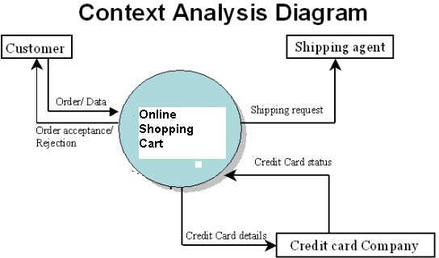

* + 1. **First Level DFD Diagram:**

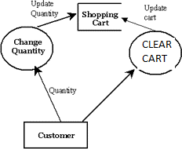

* + 1. **Second level DFD Diagram:**

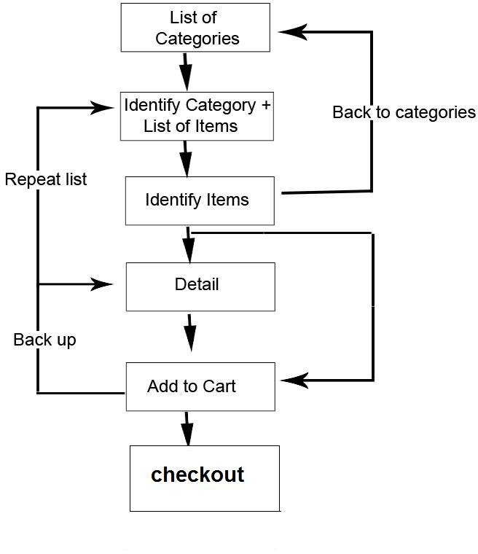

* + 1. **Login Activity Diagram:**

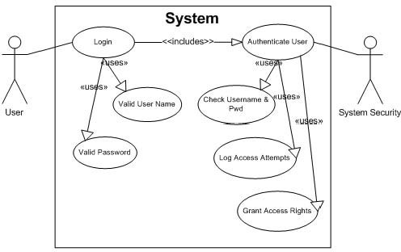

* + 1. **Implementation View:**

**Browser**

**Data Base**

|  |  |  |
| --- | --- | --- |
| **Request** | **ONLINE SHOPPING CART**  **C# Asp.Net**  **.Net Framework**  **Operating System** |  |
|  |
| **Response** |

### E-R Diagram:

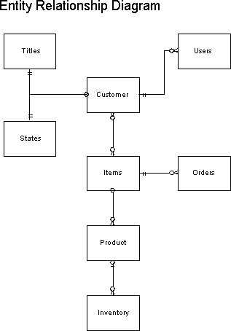

**CHAPTER 5- CONCLUSION**

The development of the software includes so many people like user system developer, user of the system and the management, It is important to identify the system requirements by properly collecting required data to interact with the system. Proper design builds upon this foundation give a blue print, which is actually implemented by the developers.

On realizing the importance of the systematic documentation all the processes are implemented using a software engineering approach. Working in a live environment enables one to appreciate the intricacies involved in the System Development Life Cycle (SDLC)).

We have gained a lot of practical knowledge from this project, which we think, shall make us stand in a good state in the future.

## REFERENCES